## Red Fir (RFR)

**General Information**

**Cover Type Overview**

**Red Fir (RFR)**

* 40,359 acres / 16,333 hectares
* Crosswalk to EVeg: Regional Dominance Type 1
  + Red Fir
* Crosswalk to EVeg: Regional Dominance Type 2
  + Any
* Crosswalk to Presettlement Fire Regime Type
  + Red Fir
* Crosswalks for Modifiers
  + Mesic
    - BpS Model: 0610321 Mediterranean California Red Fir Forest - Cascades
    - Intersects with modeled “mesic” end of the biophysical spectrum
  + Xeric
    - BpS Model: 0610322 Mediterranean California Red Fir Forest – Southern Sierra
    - Intersects with modeled “xeric” end of the biophysical spectrum
  + Ultramafic
    - This type is created by intersecting an ultramafic geology layer with the existing vegetation layer. Where cells intersect with RFR they are assigned to the ultramafic modifier.

**Red Fir with Aspen (RFR-ASP)**

* 75 acres / 30 hectares
* This type is created by overlaying the NRIS TERRA Inventory of Aspen on top of the EVeg layer. Where it intersects with RFR it is assigned to RFR-ASP.

**Vegetation Description**

**Red Fir (RFR)** TheRed Fir landcover type is characterized by the presence of *Abies magnifica*. Other conifer species such as *Pinus monticola, Pinus contorta* ssp. *murrayana*, *Tsuga mertensiana, Abies concolor,* and *Pinus jeffreyi* occur at varying densities (Landfire 2007a, Landfire 2007b).

Stand-replacing disturbances such as lightning-caused fires, windthrows, and insect and disease outbreaks kill groups of trees. Consequently, stand structure is typified by even-aged (established within 20-year span) groups of trees that cover several to thousands of square meters (Barrett 1998). Although *A. magnifica* is the climax dominant, associated conifers are frequently the post-disturbance pioneer species (Cope 1993).

Mature *A. magnifica* stands on productive sites are frequently monotypic, with very few other plant species in any layer. Heavy shade and a thick, compact layer of duff tends to inhibit most understory vegetation, especially in dense stands (Barrett 1998).

In openings resulting from tree mortality or logging, and under open stands on poor sites, many species are possible depending on location. *Ribes*, *Arctostaphylos*, *Chrysolepis sempervirens*, and *Ceanothus* are the most commonly found shrubs. Large shrubfields can dominate areas after severe fire, although conifers eventually will reclaim these sites in the absence of stand-replacing disturbance events. With some combinations of low site quality, shrub species, and resident rodent population, however, reforestation can be effectively delayed for decades (Laacke 1990).

Associated shrubs include, *Symphoricarpos rotundifolius, Lonicera conjugialis,* and *Quercus vaccinifolia*. Associated herbaceous genera include *Carex, Lupinus, Xerophyllum, Eucephalus, Pedicularis, Gayophytum, Pyrola* and *Monardella* (Cope 1993).

* **Mesic Modifer** In addition to *A. magnifica*, mesic regions within the Red Fir cover type are associated with the presence of *P. monticola* and *P. contorta* ssp. *murrayana*. *T. mertensiana* may occur on northern aspects. *A. concolor* is uncommon except at lower elevations. Shrubs are more abundant than at less productive sites, but species are similar (Landfire 2007b).
* **Xeric Modifier** These sites often include and are occasionally codominated by *A. concolor*. *P. jeffreyi*, and *P. contorta* ssp. *marayanna*, althoughother conifer species (e.g., *P. lambertiana*) can also be present in lesser amounts at lower elevations. *P. monticola* is uncommon. *A. concolor* is more prevalent at lower elevations. *P. jeffreyi* is more common on shallow soils, or when disturbance is frequent. Shrubs and herbs generally contribute less than 30% cover each. If shrub cover is higher, the shrubs are short or prostrate (Landfire 2007a).
* **Ultramafic Modifier** Ultramafic soils, found primarily in the northern mixed conifer zone, support a number of endemic plant species. Slowly growing and often stunted *P. contorta* ssp. *murrayana* and *P. jeffreyi* occur in combinations or in nearly pure open stands. Hardwoods are usually sparse, but shrubs such as *Arctostaphylos*, *Quercus*, *Rhamnus*, *Lithocarpus*, *Rhododendron,* and *Ceanothus* may occur on these sites (“CalVeg Zone 1” 2011).

**Red Fir with Aspen (RFR-ASP)** When *Populus tremuloides* co-occurs with SMC on the west side of the Sierran crest, it is typically found in smaller patches, often less than 2 ha (5 acres) in size. This variant is not subject to the modifiers described above because it is only found on mesic sites. Mature stands in which *P. tremuloides* are still dominant are usually relatively open. Average canopy closures of stands in eastern California range from 60 to 100 percent in young and intermediate-aged stands and from 25 to 60 percent in mature stands. The open nature of the stands results in substantial light penetration to the ground (Verner 1998).

**Distribution**

**Red Fir** This cover type occupies the elevational band from about 1900 to 2750 m (6000 to 9000 ft). It is bounded and integrades with Sierran Mixed Conifer at lower elevations. The upper elevations may grade into the Subalpine Conifer, Western White Pine, or Lodgepole Pine covertypes (Barrett 1998).

* **Mesic Modifer** These sites are moister and may be adjacent to meadows or riparian areas. They also tend to occupy the highest elevations.
* **Xeric Modifier** These sites are typically drier and tend to occupy the lower portion of the Red Fir zone. They are also more likely to exist on south-facing aspects.
* **Ultramafic Modifier** Ultramafics have been mapped at various spatial densities throughout the elevational range of the SMC landcover type. Low to moderate elevations in ultramafic and serpentinized areas often produce soils low in essential minerals such as calcium and magnesium or have excessive accumulations of heavy metals such as nickel and chromium. These sites vary widely in the degree of serpentization and effects on their overlying plant communities (“CalVeg Zone 1”). Note, the terms “ultramafic rock” and “serpentine” are broad terms used to describe a number of different but related rock types, including serpentinite, peridotite, dunite, pyroxenite, talc and soapstone, among others (Barbour et al. 2007).

**Red Fir with Aspen** Sites supporting *P. tremuloides* are associated with added soil moisture, i.e., azonal wet sites. These sites are often close to streams and lakes. Other sites include meadow edges, rock reservoirs, springs and seeps. Terrain can be simple to complex. At lower elevations, topographic conditions for this type tends toward positions resulting in relatively colder, wetter conditions within the prevailing climate, e.g., ravines, north slopes, wet depressions, etc. (Landfire 2007c).

**Disturbances**

**Wildfire**

**Red Fir** Fires in high-elevation *A. magnifica* forests are generally not as intense as those in the Rocky Mountains and are typically less intense than those at lower elevations. This may be a result of low annual fuel accumulation because of the short growing season. Still, fire has an important role in maintaining species diversity within *A. magnifica* forests. Fire creates canopy openings by killing mature pioneer species such as *P. contorta* ssp. *murrayana* or *P. jeffreyi* and some mature *A. magnifica*. Where these types occurs under a California red fir canopy, they are eventually succeeded by *A. magnifica.* (Cope 1993).

Data on fire return intervals (FRIs) are available from a few review papers. Skinner and Chang (1996) aggregated FRIs from the Sierra Nevada and separated pre-1850 data from total data. Van de Water and Safford’s 2011 review paper aggregates hundreds of articles, conference proceedings, and LandFire data on fire return intervals, with an emphasis on Californian sources. We also include here data from the pertinent LandFire BpS models (2007a, 2007b, 2007c, 2007d, 2007e).

The estimated fire frequency ranges from 10 to 65 years. Fires are usually patchy and of low severity. Stand-replacing fires are rare (Cope 1993). Van de Water and Safford (2011) calculated mean fire return interval of 40 years, with a median of 33, mean minimum of 15, and mean maximum of 130. These numbers are applicable to all red fir types. Skinner and Chang (1996) found median FRIs ranging from 16-20 years, minimums of 7-8 years, and a maximum of 35 years for red fir forests in the southern Cascades. The LandFire zone 7 model for Mediterranean California Red Fir Forest (2007e) estimated fire intervals of 140 years for replacement fire, 90 years for mixed fire, and 50 years for surface fire, with an overall interval of 26 years. We recalculated these numbers using condition-specific information and using only high and low mortality fire categories, which resulted in an interval of 140 years for high mortality fire, 36 years for low mortality fire, and 29 years for any fire.

The Landfire models for red fir forest in zone 6 did not include any stage-by-stage information on return intervals for any type of disturbance, or information on succession transitions without disturbance. The BPS model for zone 6 was split into 2 parts reflecting the northern and southern Sierra. The “parent” model was not included in the overall package. However, in zone 7, which abuts zone 6 to the north, the “parent” model is available (LandFire 2007e). Since many of these models were constructed or reviewed by similar people, for now I am using the numbers from zone 7. I used the proportion of land per stage from the zone 6 model. We can adjust them as per the input of our own experts. It should also be noted that the zone 7 model itself was originally derived from the zone 3 model for a similar vegetation assemblage.

* **Mesic Modifier** For red fir-white pine forests in the southern Cascades, Skinner and Chang (1996) reported a median FRI of 57 years, with a minimum of 14 years, and a maximum of 109 years. The LandFire model for Mediterranean California Red Fir Forest – Southern Sierra estimated fire intervals of 300 years for replacement fire, 320 years for mixed fire, and 80 years for surface fire, with an overall interval of 53 years (2007a).
* **Xeric Modifier** For red fir-white fir forests in the central Sierra, Skinner and Chang (1996) reported a median FRI of 11 years, with a minimum of 5 years, and a maximum of 69 years. The LandFire model for Mediterranean California Red Fir Forest – Cascades estimated fire intervals of 150 years for replacement fire, 180 years for mixed fire, and 60 years for surface fire, with an overall interval of 35 years (2007a).
* **Ultramafic Modifier** Skinner and Chang (1996) reported fire intervals for *P. jeffreyi* specifically, a characteristic species of serpentine sites that support conifers. They found a median FRI of 13 years, with a minimum of 4 and a maximum of 157. This is consistent with the general consensus that fire intervals on serpentine sites are longer and more variable than adjacent non-serpentine sites. The LandFire model for Klamath-Siskiyou Upper Montane Serpentine Mixed Conifer Woodland (2007d) gave an overall average FRI of 10 years. Most fires are predicted to be low mortality surface fires occurring frequently, about every 12 years ranging from 3-35 years. High mortality fires were modeled to recur between 100 and 400 years, with an average FRI of 250 years.

**Red Fir with Aspen** Sites supporting *P. tremuloides* are maintained by stand-replacing disturbances that allow regeneration from below-ground suckers. Upland clones are impaired or eliminated by conifer ingrowth resulting in overtopping and by intensive grazing that limits the transition from seedling to sapling. If aboveground *P. tremuloides* on upland sites disappears completely (site overtaken by conifers) due to prolonged absence of disturbance, then restoration to a *P. tremuloides* condition is not a viable pathway. In a reference condition scenario, a few stands will advance toward conifer dominance, but in the current landscape scenario where fire has been reduced from reference conditions there are many more conifer-dominated mixed aspen stands (Landfire 2007c).

Van de Water and Safford (2011) found a mean fire return interval of 19 years, median of 20 years, mean min interval of 10 years and mean max of 90 years for Aspen. The LandFire model for northern Sierra Nevada aspen that is seral to conifers generated a mean return interval of 94 years for high mortality fire, 58 years for low mortality fire, and 36 years overall (2007c).

Table 1. RFR, RFR-ASP Fire return intervals (years) and percentage of high versus low mortality fires in relation to soil type modifier and the presence of *Populus tremuloides*. Numbers for RFR on mesic sites were derived from BpS model 0610322 and Skinner and Chang (1996). Numbers for RFR on xeric sites were derived from BpS model 0610321 and Skinner and Chang (1996). Numbers for RFR on ultramafic sites were derived from BpS model 0310220. Numbers for RFR-ASP were derived from BpS model 0610610 and Van de Water and Safford (2011).

|  |  |  |  |  |  |  |
| --- | --- | --- | --- | --- | --- | --- |
| **Variant** | **Modifier** | **Fire Severity** | **Average** | **Min** | **Max** | **% of Fires** |
| **RFR** | Mesic | High | 142 |  |  | 18 |
| Low | 31 |  |  | 82 |
| All Fires | 26 | 14 | 109 |  |
| Xeric | High | 140 |  |  | 21 |
| Low | 36 |  |  | 79 |
| All Fires | 27 | 5 | 69 |  |
| Ultramafic | High | 50 |  |  | 18 |
| Low | 11 |  |  | 82 |
| All Fires | 9 | 4 | 157 |  |
| **RFR-ASP** | n/a | High | 99 |  |  | 37 |
| Low | 58 |  |  | 63 |
| All Fires | 37 | 5 | 90 |  |

**Other Disturbance**

Other disturbances are not currently modeled, but may, depending on the condition affected and mortality levels, reset patches to early development, maintain existing stages, or shift/accelerate succession to a more open stage.

**Vegetation Condition Classes**

**Red Fir Variant**

**Early Development (ED)**

***Description*** This condition is characterized by the recruitment of a new cohort of early successional, shade-intolerant tree species into an open area created by a stand-replacing disturbance. Conifer associates regenerate from seed. Occasionally, large brush fields may develop after hot wildfires and are dominated by *Ceanothus*, *Arctostaphylos*, *Chrysolepsis*, or other shrub species for many years (Barrett 1998). On mesic sites, *P. monticola* and *P. contorta* ssp. *murrayana* regenerate from seed. *A. magnifica* comes in over time. Shrub cover is an important component (Landfire 2007b). On xeric sites, there is regeneration of *A. magnifica* and *A. concolor*, perhaps *P. jeffreyi* or *P. lambertiana* from seed. Shrub cover varies. Herbs are often sparse due to competition for soil moisture on light soils (Landfire 2007a). Ultramafic sites will have similar species composition, especially at edges, but *P. jeffreyi*, are relatively more common Shrubs and herbs are sparse. (Barbour et al. 2007).

##### ***Succession Transition***

* 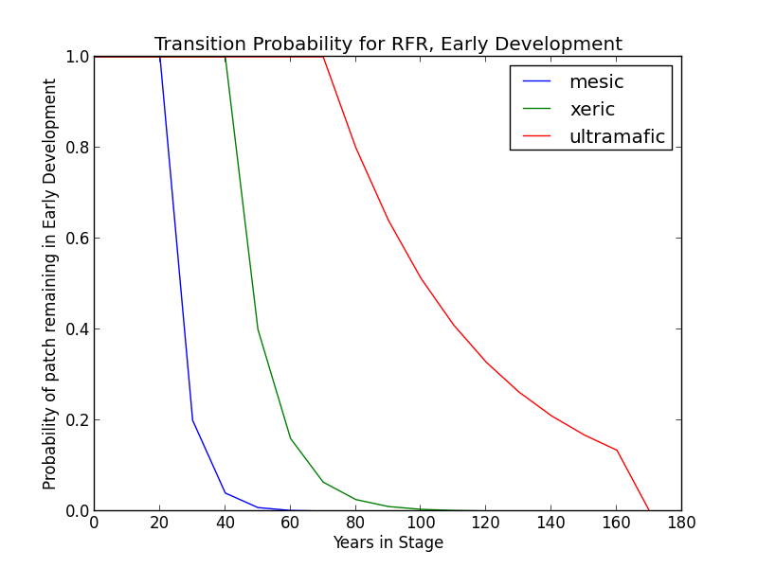**Mesic Modifier** In the absence of disturbance, this class will begin transitioning to MDC at age 30 with a probability of 0.8 that a patch will succeed. After 70 years, all stands will have succeeded to MDC.
* **Xeric Modifier** Transition to the MD conditions may be somewhat delayed. In the absence of disturbance, this class will begin transitioning to MDO after 50 years and may be delayed in the ED stage for as long as 150 years. A stand in this condition has a probability of 0.6 that it will succeed.
* **Ultramafic Modifier** Transition to the MD condition may be substantially delayed. Thus, in the absence of disturbance, this class will begin transitioning to MDO after 80 years and may be delayed in the ED stage for as long as 150 years. A stand in this condition has a probability of 0.2 that it will succeed.

***Wildfire Transition*** High mortality wildfire (100% of fires) recycles the patch through the Early Development stage. Low mortality wildfire is not modeled for this stage.

**Mid Development - Open (MDO)**

***Description*** The pole/medium tree stage produces dense stands of young red fir that grow slowly with little mortality for many years (Barrett 1998). Cover of grasses, forms, and shrubs is on the decline as conifer canopy cover ranges from 10-40%. *A. magnifica* either is or is transitioning to become the dominant tree species (Landfire 2007a; Landfire 2007b).

On mesic sites, *P. monticola* and *P. contorta* ssp. *murrayana* are present in varying amounts. Grasses, forbs, and shrubs are declining, although chaparral type shrubs, such as *Arctostaphylos* or *Chrysolepsis* can contribute to a dense understory. On xeric sites, *A. concolor* and *P. jeffreyi* are present in varying amounts, and shrub cover varies (Landfire 2007a; Landfire 2007b). Ultramafic sites will have similar species composition, especially at edges, but *P. jeffreyi* is relatively more common (Barbour et al. 2007).

***Succession Transition***

* **Mesic Modifier**  In the absence of low mortality disturbance, MDO will begin transitioning to MDC after 20 years at a rate of 90%. Succession to LDO takes place after 80 years since entering a middle development stage.

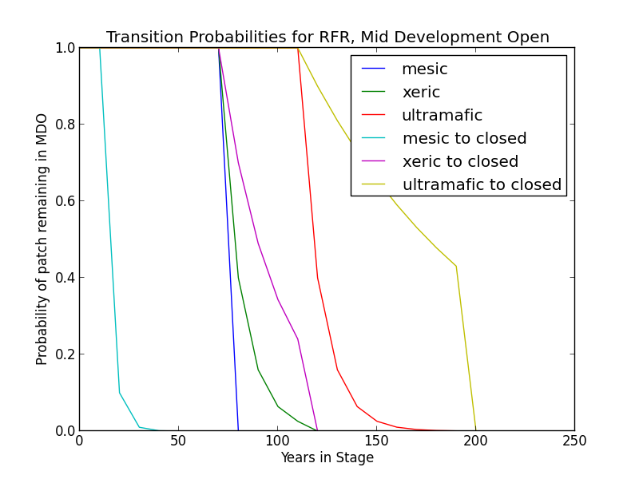

* **Xeric Modifier** In the absence of low mortality disturbance, MDO will begin transitioning to MDC after 50 years at a rate of 30%. Succession to LDO takes place variably beginning at 80 years since transition to middle development with a probability of 0.6 per timestep. All patches succeed to the late condition by 100 years.
* **Ultramafic Modifier** In the absence of low mortality disturbance, MDO will begin transitioning to MDC after 80 years at a rate of 10%. Succession to LDO takes place variably beginning at 120 years (60% chance per timestep) since transition to middle development, and all patches succeed by 180 years.

***Wildfire Transition***

* **Mesic Modifier** High mortality wildfire (17.4% of fires) returns the patch to Early Development. Low mortality fire (82.6%) maintains the MDO condition and allows for succession to LDO.
* **Xeric Modifier** High mortality wildfire (11.8% of fires) returns the patch to Early Development. Low mortality fire (88.2%) maintains the MDO condition and allows for succession to LDO.
* **Ultramafic Modifier** High mortality wildfire (5.6% of fires) returns the patch to Early Development. Low mortality fire (94.4%) maintains the MDO condition and allows for succession to LDO.

**Mid Development – Closed (MDC)**

***Description*** The pole/medium tree stage produces dense stands of young red fir that grow slowly with little mortality for many years (Barrett 1998). Cover of grasses, forms, and shrubs is on the decline as conifer canopy cover exceeds 40%. *A. magnifica* either is or is transitioning to become the dominant tree species. On mesic sites, *P. monticola* and *P. contorta* ssp. *murrayana* are present in varying amounts, while on xeric sites *P. jeffreyi* and *A. concolor* are associates. *P. jeffreyi* is the most likely associate on ultramafic sites (Landfire 2007a, Landfire 2007b).

***Succession Transition***

* 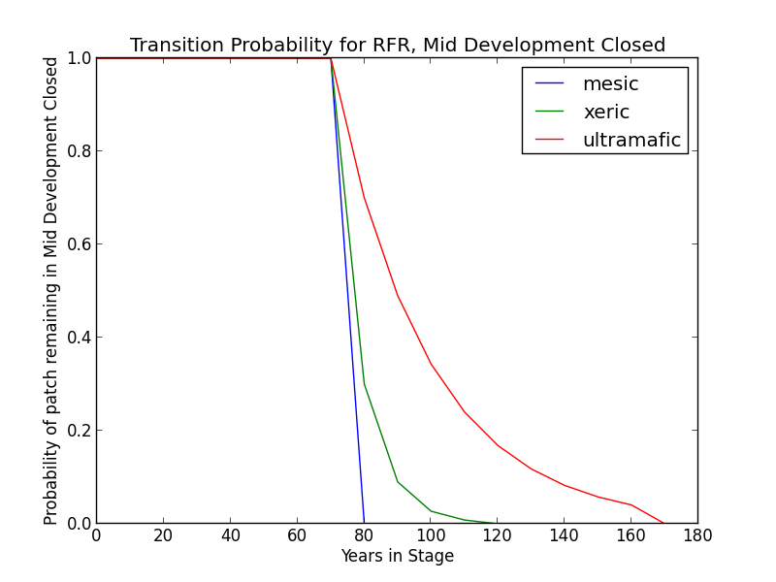**Mesic Modifier** MDC persists for 80 years on productive soils and in the absence of fire, at which point all stands transition to LDC. Stands that transitioned to MDC from MDO transition to LDC once the time since transition to a mid development stage is at least 80 years.
* **Xeric Modifier** Transition to late seral conditions may be delayed. Thus, on unproductive soils, in the absence of disturbance, this class will begin transitioning to LDC after 80 years at a rate of 70% per time step and may be delayed in the MDC stage for up to 100 years.
* **Ultramafic Modifier** Transition to late seral conditions may be substantially delayed. Thus, in the absence of disturbance, this class will begin transitioning to LDC after 80 years at a rateof 30% per time step and may be delayed in the MDC stage for up to 150 years.

***Wildfire Transition***

* **Mesic Modifier** High mortality wildfire (15.1% of fires) returns the patch to ED. Low mortality wildfire (84.9%) opens the stand up to MDO 66.7% of the time; otherwise, the patch remains in MDC.
* **Xeric** **Modifier** High mortality wildfire (15.1% of fires) returns the patch to ED. Low mortality wildfire (84.9%) opens the stand up to MDO 66.7% of the time; otherwise, the patch remains in MDC.
* **Ultramafic Modifier** High mortality wildfire (5.3% of fires) returns the patch to ED. Low mortality wildfire (94.7%) opens the stand up to MDO 7.4% of the time; otherwise, the patch remains in MDC.

### Late Development – Open (LDO)

##### ***Description*** In the large tree stage, subdominant trees die and add to a growing layer of duff and downed woody material, and dominant trees continue to grow for several hundred years. Old growth stands on poor sites may still average about 400 years old. *A. magnifica* is the most common tree species. The understory of mature stands may be limited to less than 5% cover (e.g. *Chimaphila menziesii, Pyrola picta*).This condition develops when low-mortality disturbance is fairly frequent; it persists as long as low-mortality fires continue to occur periodically. *Ceanothus* and *Arctostaphylos* populate disturbance-generated gaps. (Landfire 2007a, Landfire 2007b)

On mesic sites, *P. monticola* and *P. contorta* ssp. *murrayana* may comprise up to 20% of tree cover each. *P. contorta* ssp. *murrayana* acts as the pioneering conifer. On xeric sites, *A. concolor* and *P. jeffreyi* are the common associates and pioneer conifer species after disturbance (Barrett 1998, Landfire 2007a, Landfire 2007b). Ultramafic sites will have similar species composition, especially at edges, but *P. jeffreyi* is relatively more common. (Barbour et al. 2007)

##### ***Succession Transition***

* **Mesic Modifier**  In the presence of low mortality disturbance, this condition can self-perpetuate, but after 20 years with no fire, patches in this condition will begin transitioning to LDC. Probability per time step is 0.9.
* 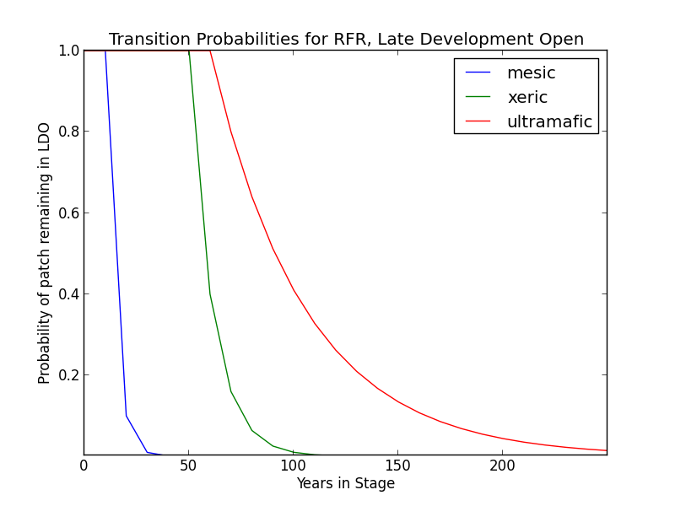**Xeric Modifier** Patches occurring on low productivity soils may succeed to LDC after 50 years with no fire; the probability is 0.6 per time step.
* **Ultramafic Modifier** Patches occurring on ultramafic soils may succeed to LDC after 70 years with no fire, but the probability is just 0.2 per time step.

##### ***Wildfire Transition***

* **Mesic Modifier** High mortality wildfire (17.4% of fires) returns the patch to early development. Low mortality wildfire (82.6%) maintains LDO.
* **Xeric Modifier** High mortality wildfire (2.5% of fires) returns the patch to early development. Low mortality wildfire (97.5%) maintains LDO.
* **Ultramafic Modifier** High mortality wildfire (2.3% of fires) returns the patch to early development. Low mortality wildfire (97.7%) maintains LDO.

**Late Development – Closed (LDC)**

***Description*** In the large tree stage, subdominant trees die and add to a growing layer of duff and downed woody material, and dominant trees continue to grow for several hundred years to heights of 40 m (130 ft). Overall conifer cover exceeds 40%. Old growth stands on poor sites may still average about 400 years old. *A. magnifica* is the most common tree species. The understory of mature stands is limited to less than 5 percent cover of shade tolerant forbs (e.g., *Chimaphila menziesii*, *Pyrola picta*).

On mesic sites, *P. monticola* is the primary associate, with some *P. contorta* ssp. *murrayana* occuring in the understory. On xeric sites, *A. magnifica* occurs in pure to mixed stands, and *A. concolor* and *P. jeffreyi* are the primary associates (Barrett 1998, Landfire 2007a, Landfire 2007b). Ultramafic sites will have similar species composition, especially at edges, but *P. jeffreyi* is relatively more common. (Barbour et al. 2007)

Areas with aspen are now overtopped by *A. magnifica* or *A. concolor*. Some decadent aspen may persist, but without disturbance the clone will not replace itself.

***Succession Transition*** In the absence of disturbance, this class will maintain, regardless of soil characteristics.

***Wildfire Transition***

* **Mesic Modifier** High mortality wildfire (25.4% of fires) will return the patch to Early Development. Low mortality wildfire (74.6%) opens the stand up to LDO 75% of the time; otherwise, the patch remains in LDC.
* **Xeric Modifier** High mortality wildfire (14.5% of fires) will return the patch to Early Development. Low mortality wildfire (85.5%) opens the stand up to LDO 75% of the time; otherwise, the patch remains in LDC.
* **Serpentine Modifier** High mortality wildfire (10% of fires) will return the patch to Early Development. Low mortality wildfire (90%) usually has little effect, although 7.4% of the time it opens the stand up to LDO.

**Aspen Variant**

**Early Development – Aspen (ED–A)**

***Description*** Grasses, forbs, low shrubs, and sparse to moderate cover of tree seedlings/saplings (primarily *P. tremuloides*) with an open canopy. This condition is characterized by the recruitment of a new cohort of early successional, shade-intolerant tree species into an open area created by a stand-replacing disturbance.

Following disturbance, succession proceeds rapidly from an herbaceous layer to shrubs and trees, which invade together (Barrett 1998). *P. tremuloides* suckers over 6ft tall develop within about 10 years (LandFire 2007c).

***Succession Transition*** Unless it burns, a patch in the early stage persists for 10 years, at which point it transitions to MDC-A.

***Wildfire Transition*** High mortality wildfire (100% of fires) recycles the patch through the Early Development – Aspen stage. Low mortality wildfire is not modeled for this stage.

**Mid Development – Aspen (MD–A)**

***Description*** *P. tremuloides* trees 5-16” DBH. Canopy cover is highly variable, and can range from 40-100%. These patches range in age from 10 to 150 years and could maintain indefinitely. Some understory conifers, including *P. contorta* ssp. *murrayana, A. concolor*, and *A. magnifica* are encroaching, but *P. tremuloides* is still the dominant component of the stand (LandFire 2007c).

***Succession Transition*** MD-A persists for at least 50 years in the absence of fire, after which stands begin transitioning to MD-AC at a rate of 0.7 per timestep. At age 100 all remaining MD-A patches transition to MD-AC.

***Wildfire******Transition*** High mortality wildfire (100% of fires) recycles the patch through the Early Development – Aspen stage. Low mortality wildfire is not modeled for this stage.

**Mid Development – Aspen with Conifer (MD–AC)**

***Description*** These stands have been protected from fire for at least 100 years. *P. tremuloides* trees are predominantly 16” DBH and greater. Conifers are present and overtopping the aspen. *Abies concolor* is a typical conifer that is successional to aspen, and is depicted here, but other conifers including *P. contorta* ssp. *murrayana* and *A. magnifica* are also possible. Conifers are pole to medium-sized, and conifer cover is at least 40% (LandFire 2007c).

***Succession Transition*** MD-AC persists for 100 years in the absence of fire, after which stands transition to LDC.

***Wildfire Transition*** High mortality wildfire (28.4% of fires) returns the patch to ED-A. Low mortality wildfire (71.6%) maintains the patch in MD- AC.

**Late Development – Closed (LDC)**

***Description*** Some *P. tremuloides* continue to be present in the understory, but large conifers are now the dominant tree species, having overtopped the *P. tremuloides.* Smaller conifers are present in the midstory as well. Conifer species likely present include *A. concolor, A. magnifica,* and *P. contorta* ssp. *murrayana*. (Landfire 2007a).

***Succession Transition*** See description of same stage under Sierran Mixed Conifer Variant

***Wildfire Transition*** High mortality wildfire (31.2% of fires) will return the patch to Early Development - Aspen. Low mortality wildfire (68.8%) maintains the current condition.

**Late Development – Fire-Maintained Aspen with Conifer (LD– FMAC)**

***Description*** If stands are sufficiently protected from fire such that conifer species overtop *P. tremuloides* and become large, they may be able to withstand some fire that more sensitive *P. tremuloides* cannot. When this occurs, it creates a patch characterized by late development conifers, such as *A. concolor* or *A. magnifica*, and early seral *P. tremuloides*.

***Succession Transition*** LD-FMAC persists for 70 years in the absence of fire, after which stands transition to LDC.

***Wildfire Transition*** High mortality wildfire (9% of fires) returns the patch to ED-A. Low mortality wildfire (91%) maintains the stand in LD-FMAC. [Note, recently added and relative fire probabilities have not been recalculated to include this stage.]

**Condition Classification**

Table 2. Cover Condition for SMC and the attributes from EVeg used to assign that condition. Each row should be read with a boolean AND across each column of a row.

|  |  |  |  |  |  |
| --- | --- | --- | --- | --- | --- |
| Cover Condition | Overstory Tree  Diameter 1 (DBH) | Overstory Tree  Diameter 2 (DBH) | Total Tree  CFA (%) | Conifer  CFA (%) | Hardwood  CFA (%) |
| Early All | null | any | any | any | any |
| Early All | 0-5.9” | any | any | any | any |
| Mid Open | 5-19.9” | any | null | null | null |
| Mid Open | 5-19.9” | any | <40 | any | any |
| Mid Open | 5-19.9” | any | null | <40 | null |
| Mid Closed | 5-19.9” | any | >40 | any | any |
| Mid Closed | 5-19.9” | any | null | >40 | any |
| Late Closed | 20”+ | any | >40 | any | any |
| Late Closed | 20”+ | any | null | >40 | any |
| Late Open | 20”+ | any | null | null | null |
| Late Open | 20”+ | any | <40 | any | any |
| Late Open | 20”+ | any | null | <40 | null |

**Draft Models**

See PDF – Disturbance-Succession model for RFR and RFR-ASP

**References**

Barbour, Michael, Keeler-Wolf, Todd, and Schoenherr, Allan A., eds. *Terrestrial Vegetation of California, 3rd Edition*. 2007.

Barrett, Reginald H. “Red Fir (RFR).” *A Guide to Wildlife Habitats of California*. 1988. Mayer, Kenneth E. and Laudenslayer, William F., eds. California Deparment of Fish and Game. <http://www.dfg.ca.gov/biogeodata/cwhr/pdfs/SMC.pdf>. Accessed 4 December 2012.

“CalVeg Zone 1.” Vegetation Descriptions. *Vegetation Classification and Mapping*. 11 December 2008. U.S. Forest Service. <http://www.fs.usda.gov/Internet/FSE_DOCUMENTS/fsbdev3_046448.pdf>. Accessed 2 April 2013.

Cope, Amy B. 1993. “Abies magnifica.” In: Fire Effects Information System, [Online]. U.S. Department of Agriculture, Forest Service, Rocky Mountain Research Station, Fire Sciences Laboratory (Producer). <http://www.fs.fed.us/database/feis/> [Accessed 4 December 2012].

Laacke, Robert J. “California Red Fir.” Burns, Russell M. and Barbara H. Honkala, tech. coords. Silvics of North America, vol 1. Conifers; Glossary. Agriculture handbook no.654. Washington, D.C. : U.S. Dept. of Agriculture, Forest Service, 1990.

LandFire. “Biophysical Setting Models.” Biophysical Setting 0610321. Zone 6. 2007a. LANDFIRE Project, U.S. Department of Agriculture, Forest Service; U.S. Department of the Interior. <http://www.landfire.gov/national_veg_models_op2.php>. Accessed 9 November 2012.

LandFire. “Biophysical Setting Models.” Biophysical Setting 0610322. 2007b. LANDFIRE Project, U.S. Department of Agriculture, Forest Service; U.S. Department of the Interior. <http://www.landfire.gov/national_veg_models_op2.php>. Accessed 9 November 2012.

LandFire. “Biophysical Setting Models.” Biophysical Setting 0610610. 2007c. LANDFIRE Project, U.S. Department of Agriculture, Forest Service; U.S. Department of the Interior. <http://www.landfire.gov/national_veg_models_op2.php>. Accessed 7 January 2013.

LandFire. “Biophysical Setting Models.” Biophysical Setting 0310220. 2007d. LANDFIRE Project, U.S. Department of Agriculture, Forest Service; U.S. Department of the Interior. <http://www.landfire.gov/national_veg_models_op2.php>. Accessed 30 November 2012.

LandFire. “Biophysical Setting Models.” Biophysical Setting 0711720. 2007e. LANDFIRE Project, U.S. Department of Agriculture, Forest Service; U.S. Department of the Interior. <http://www.landfire.gov/national_veg_models_op2.php>. Accessed 30 November 2012.

Skinner, Carl N. and Chang, Chi-Ru. “Fire Regimes, Past and Present.” *Sierra Nevada Ecosystem Project: Final report to Congress, vol. II, Assessments and scientific basis for management options*. Davis: University of California, Centers for Water and Wildland Resources, 1996.

Van de Water, Kip M. and Safford, Hugh D. “A Summary of Fire Frequency Estimates for California Vegetation Before Euro-American Settlement.” *Fire Ecology* 7.3 (2011): 26-57. doi: 10.4996/fireecology.0703026.

Verner, Jared. “Aspen (ASP).” *A Guide to Wildlife Habitats of California*. 1988. Mayer, Kenneth E. and Laudenslayer, William F., eds. California Department of Fish and Game. <http://www.dfg.ca.gov/biogeodata/cwhr/pdfs/SMC.pdf>. Accessed 4 December 2012.